The U.S organization that I want to analyze is GameStop. I had the experience of working there and a few years ago when the company was one of the top-sellers of gaming products in the United States and it also has stores outside of the United States. Since the new generations are increasingly technologically-savvy, the gaming business will continue to boom. This company with such potential was not taking advantage of the current market trends, proven by the fact that this previous top-seller was almost in bankruptcy before the COVID-19 pandemic. Microsoft bought the company in 2020 because it knows the revenue that this store can generate working in a more efficient way and using the right metrics to understand what is happening with the new trends in customer behaviors. Unfortunately, having the experience of working on the company I was able to see that the organization wasn’t able to adapt to new customers trends that is being making GameStop to losses against big companies like Amazon or BestBuy were in the past the company was a top seller on the gaming products. Part of this problem is that GameStop don’t have plan amid the use of business tools that can help the company to find the new trends and give the company key insight and metrics that GameStop will need in order to take decision that are more adjust the reality. Also, will help the company to see the holes that the company has in every department and make changes that will help to covert the company in a more efficient, sustainable and with a better decision making in the company.

The problem that the company is facing is that the company still focus in their overprioritizes its brick-and-mortar footprint and stumbles around the online ecosystem. This means that GameStop is not being able to adapt and understand the new trends that the customer wants the store to become, this process accelerates because the pandemic where population see the use of the online store more that and convenience services, customers are looking to buy online because a necessity and safety reasons. This is causing that the company will need close more and more store, a research from the Miami Herald said that by the end of the latest fiscal year, GameStop will have closed over 1,000 stores since mid-2019. That means that the store is not generating the enough revenues to keep that whole infrastructure open. Also is causing that company can’t redirect resources to other important areas like marketing, promotions and the improve of operations and the online store. These problems are causing that GameStop don’t the ability to compete with Best Buy, Amazon or Walmart. Also, the inexistence of tools that can help to understand what customers want is making the company to take wrong decision that are not having the result that the company is looking for. Instead, the company is being taking aggressive decision that are making the store instead of offering different experience for the customer a more team that just want to sells because the need of selling the products to help the company to being able to keep up the company sustainable.

In order to understand the challenges that the company is facing. The company will need to focus in choosing dataset that are the best fit to analyze and have better decision making in the company that will help to the company to change their path and make it more sustainable o profitable. The data set that will help to take advantage of the business Intelligence tools are:

* Sales
* Expenses
* Gross Profit
* Employees
* Revenue per Employee
* Operation Earnings
* Net Income
* Current Ratio

The use of these data set history of the company will give a better understanding the performance of the sale trough the years. This information will help to the company to understand if any of the change or different strategies that were used were able to improve the sales of the company. Also, can help GameStop to measure how well the company is handling the cost of operation of the company. The use of current information information can be used to have an idea if the is able to generate enough revenue to cover all the responsibilities of the company.

* Gross Profit: This data will allow to understand the real profit of the company and evaluate how efficient the operations are trough the company.
* Employees:

This information will be gathered daily in the system and trough visualization tool that will linked with the data set. The visualization tools will allow the company to have a more understandable data that can be access a every moment helping management to understand the performance of the company daily. This information will create insight at the moment, daily weekly, monthly and yearly. Helping to understand which hours are more demanding depending the store, the days and months that are busier. This information will allow the company to change schedules of the employees to have a more support that days and months helping to maximize the sales and the customer impact on the stores. Also, it will help to set days that are lees busy to focus in the operations procedure of the stores and the receiving of the products

It’s a lot of good option related with BI tool(s) in the market, but the company will need to take in consideration that the teams are not specialist on data analysis and interpretation of the data. In order to perform this project, the company will need to have data analysis team that will be in charge of delivering this metrics to the departments that need this information for daily procedures. Taking this in consideration the best BI tool that is suitable for GameStop is SAS, for the use of this program the user doesn’t need to have a high expertise in coding. Because the program creates the codes for you. Also, the system that GameStop is currently using(oracle) is compatible with SAS that means that the company will be able to extract the data that they need in every scenario. In this case because the limitations on the data that I was able to find from the company didn’t include customers and online store sales. But with the data that’s was able to find is enough to prove my hypothesis that GameStop need change drastically their strategies, like their competitor did.

Summary Statistics

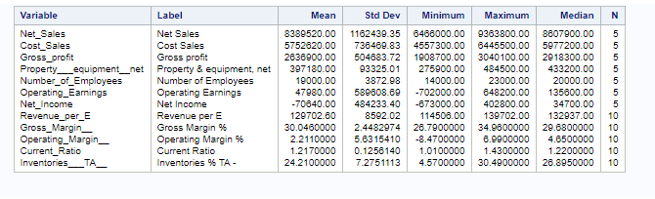

Plots

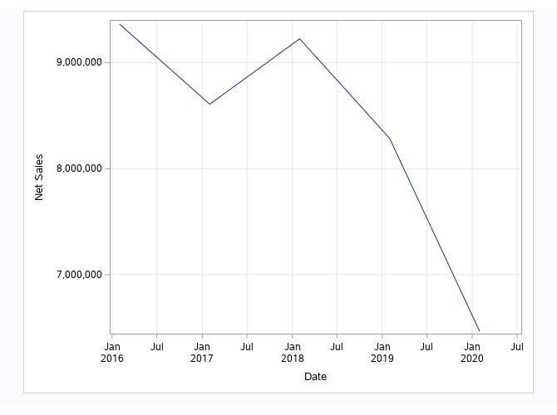

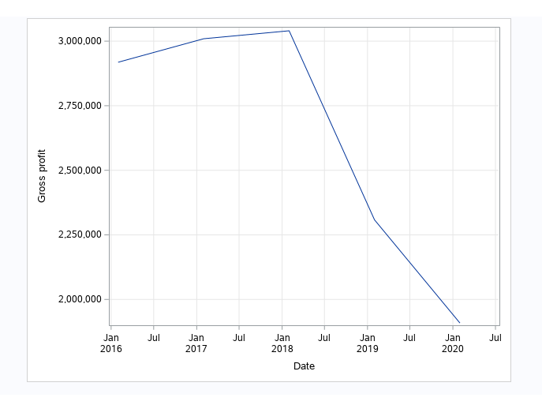

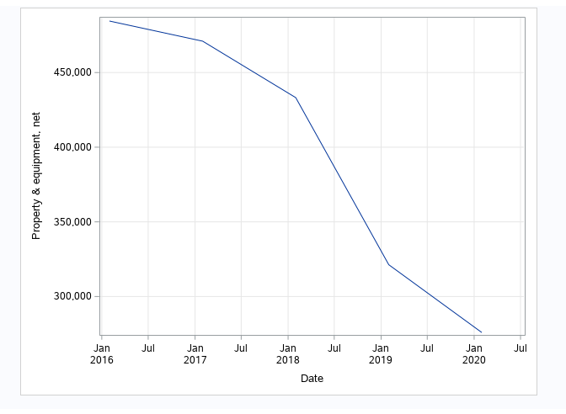

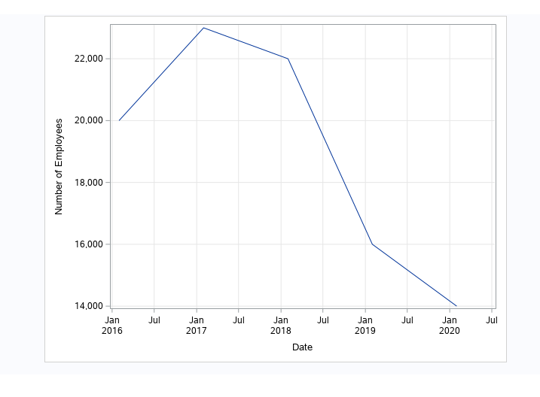

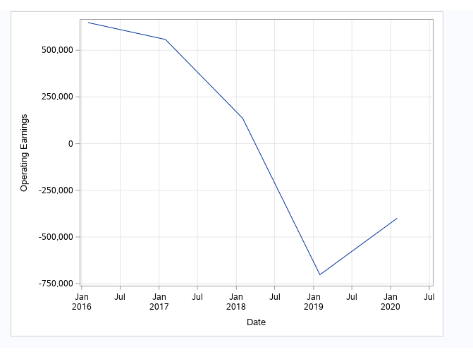

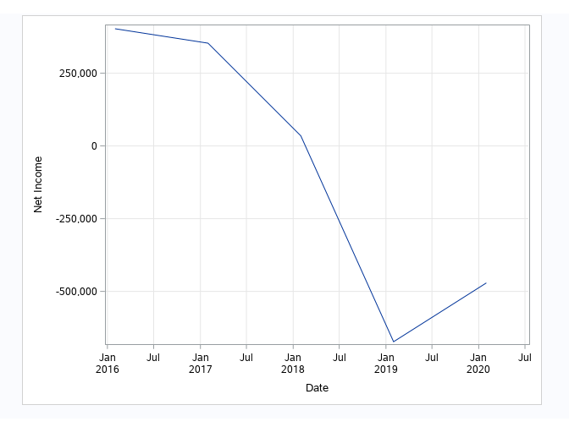

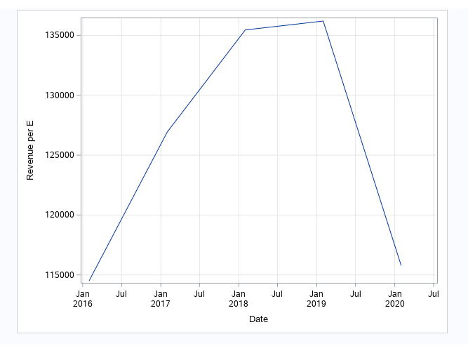

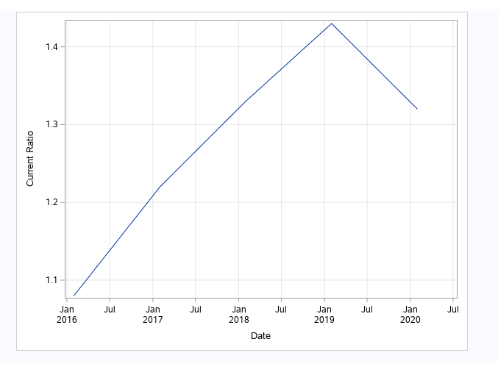

Using a series of plots, we can see how the company is being taking a series of strategies related with reducing staffing and the space that they owned meaning that is being significant change in the properties that GameStop possess. change in the properties that GameStop possess. It is true that the ratio that company possess it is still positive but it’s not a sign that the company is recovering. They are able to use the money that the obtain reducing their properties and employees to cove debs and to keep being able to run the company. Also, we can see that in the operation area reducing of employees and because the company is being constantly reducing their store. If the strategies were working the earnings in operation at least will be in green number, but the strategies are not working. And we can confirm this hypothesis looking at the net sales of the company where it shows that any of the change that the company is taking in place is working in solve the monetary issues that the company has and the inexistence of new ideas that can bring the business back to be a sustainable company.

Best Buy Comparation

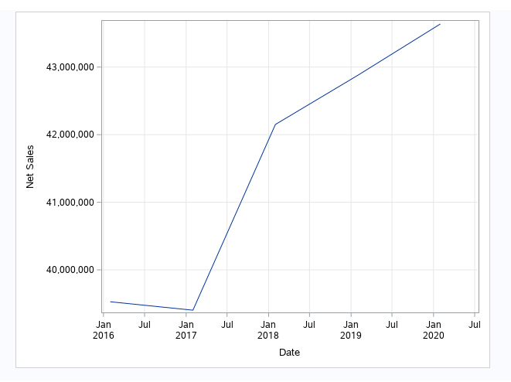

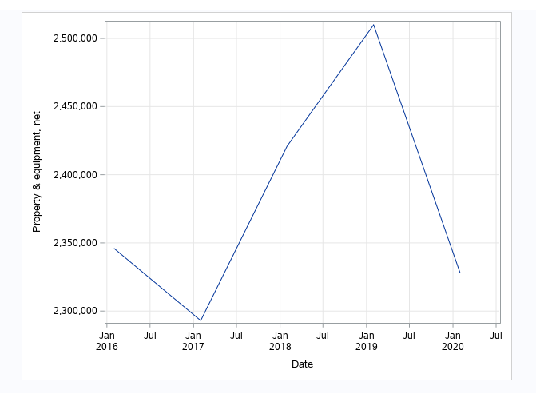

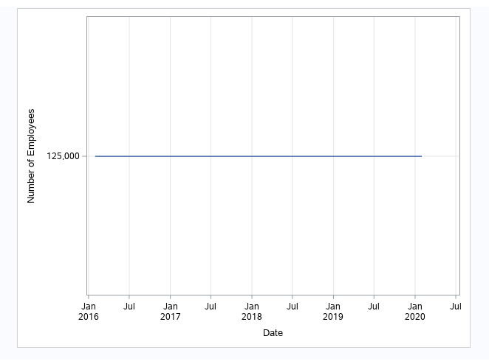

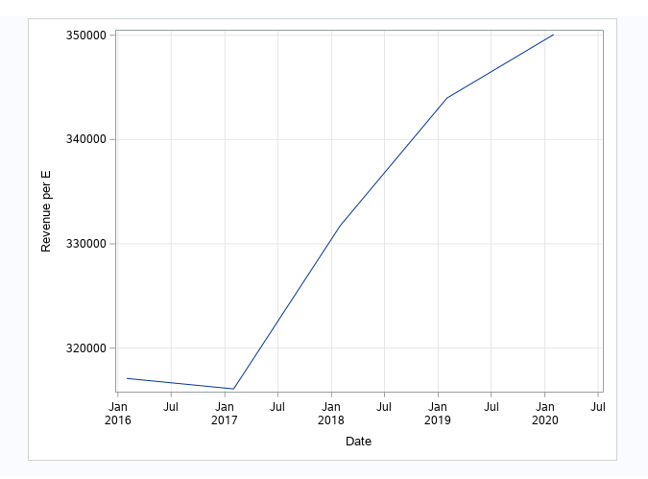

Best Buy is one of GameStop competitors that their strategies are completely different. Best Buy is focus in develop a better online store and trying to simply procedures make things easier for the customer, that result a better customer experience. In their data we can see how Best Buy is being stable even trough this pandemic, the have the same level of employees that are being productive for the company and growing their productivity in consistent way. That means that Best is being to understand the new customer trends and use this metrics to change their strategies and prepare for future.

The use of BI tools is critical for company to understand how the business is doing. We a clear example with GameStop the recent surge of the stock market doesn’t have any fundamentals, meaning that the company is not doing well in the model of business that they are trying to implement. Every strategy that GameStop is being trying to use is not ben able to stabilize the monetary issues and the attract more customers. BI tools helped to understand the reality of the company and the market. Helping the company to take decision that are attach to the reality, in this world that is changing constantly companies need to be able to also change quickly and reinvent themselves, because customer is constantly changing their behaviors. The use BI tools help to predict future scenarios that can help the company to avoid or reduce the risk of face challenging scenario like the one that GameStop is facing. But the company will need to be willing to change and try new ideas because if not it doesn’t matter the tools that they have they are not going to be able to meet the goals that company want to pursuit.